Node JS, Express & MongoDB

NodeJs –

* Runtime Application.
* Server javascript
* Asynchronous events (non blocking)
* Non-blocking I/O

**Require**: function – use to import other nodejs modules

**Path**: module comes with node – gives us some tools to work with paths

**Process**: object – interact with current process instance –

* process.argv.indexOf(flag);
* process.stdout.write(‘hello’); - to write it to stdout
* process.stdin.on('data', function(data){})

**Http**:  designed to be the simplest way possible to make http calls

We need to add meta data for header and response

// Configure our HTTP server to respond with Hello World to all requests.

var server = http.createServer(function (request, response) {

response.writeHead(200, {"Content-Type": "text/plain"});

response.end("Hello World\n");

});

Npm: package manager for nodejs:

* Require – includes the external packages in nodejs application
* Driver: library in a specific language. Here it communicates with the MongoDB server
* 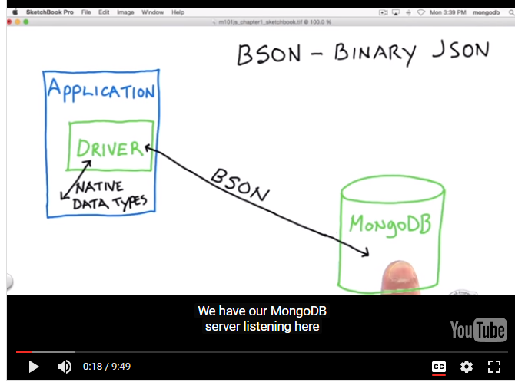

Express:

Frame work. It handles routing, request param and other details of HTTP requests, and provides API to work with requests more easily to handle requests.

* Streamlined NodeJS - make things faster
* Adds server methods – popular modules
* Routing mechanism – different type of request
* Easier APIs – easier to create an API
* Middleware friendly –other modules
* Easy access to public files

Creating Routes:

* App.get();
* Pass variables res.params

**router.get**('/speakers/:speakerid', function(**req, res**) {

var **dataFile** = req.app.get('appData');

var speaker = dataFile.speakers[req.params.speakerid];

**res.send**(`

<h1>${speaker.title}</h1>

<h2>with ${speaker.name}</h2>

<p>${speaker.summary}</p>

`);

});

One of the best features of Express is how easy it is to work with routing. Routing allows you to give users access to different types of data, and we can pass along information to the routes through the params variable of the request object.

Modularization

* NodeJS makes it super simple to build modules with built-in methods that let you import and output content.
* Require() - lets you import one document into another

var express = require('express'); - express library into the module.

var router = express.Router(); -- to use the router object of the Express library so that I can work with these external routes.

* module.exports - allows you to export the contents of a module.

module.exports = router ; We have to use this router object, and in order for our app.js file to get everything in this route, we're gonna need to export the router object.

* app.use() - Within Express, the use method allows our application to use external routes as part of the application.

Ex : ----- app.use(require('./routes/index'));

* Express.Router() - router object provided by the Express library to create an instance of the route. This makes the route mountable by our original application,
* app.set() - The set method of your app can create variables that then can be passed to your routes.

app.set('port', process.env.PORT || 3000 );

app.set('appData', dataFile); -- app information is going to be available through our request

* req.app.get() - That information can be passed along to your modules through the request object that is going to be generated when you call the application.

var dataFile = req.app.get('appData'); the app information and then use a get command to get this variable that I created in my main application called appData.

Public Folders:

Express Middleware

* Middleware is any library that can be called as part of the process of working with a site that then returns control back to Express.
* express.static() -  it allows you to designate a folder for holding any sort of document or file that we want our users or our routes to have access to

app.use(express.static('app/public')); use an app.use command and then I'll use express.static and that is a method that Express has that will allow us to designate a folder.

Workflow Automation

* watch for changes
* reload browser
* use package.json script -- Nodemon & Reload – npm install –g nodemon

nodemonitor – Nodemon

package.json

"start": "nodemon -e css,ejs,js,json --watch app"

So for example, you may not want to do anything if somebody updates any markdown documents, like their readme file, it doesn't really belong to the server and so you can just specify certain extensions, so for example, just the CSS files,EJS documents, JavaScript files, or JSON documents.

**Reload**

So what about that reloading of the page? It's sort of annoying that it is noticing the changes, but it doesn't do anything else with the browser. So to get that working, we need to install this other npm plugin, called Restart. So I'm gonna cancel this. So I'm gonna issue an npm install -g to install this locally. And the package I need is called reload.

Npm install –g reload --- globally

Npm install –save reload --- to install this as a dependency for the project.

App.js

Var reload =require(‘reload’);

Reload(server,app);

Index.js

<script src=”/reload/reload.js”></script>

Template libraries

**Consolidate:** template engine

app.engine('html', engines.nunjucks); 🡪 registering nunjucks template engine with html extension

app.set('view engine', 'html'); 🡪 to render our html file by using above engine

app.set('views', __dirname + '/views'); 🡪 where our templates are located.

__dirname 🡪 nodejs environment variable - where to look for views

res.render('hello', { name : 'Templates' });🡪 use render the template to use and give an object in which we will pass the value to the variable in the template

**Bodyparser:** middleware with express. Telling express to do extra processing the body of route

**MongoDB connection from NodeJS**

var MongoClient = require('mongodb').MongoClient,

assert = require('assert');

MongoClient.connect('mongodb://localhost:27017/crunchbase', function(err, db) {})

We can replace localhost with name or ip address of that host

//to get all the records at once from DB

db.collection('companies').find(query).toArray(function(err, docs) {})

//to get one records at a time from DB

var cursor = db.collection('companies').find(query);

cursor.forEach(function(doc) {})